MobileCirc FAQs:

*How do I get MobileCirc?
Talk to Pete or Melissa. We’ll make sure you have a device that’s compatible with the current version of MobileCirc: in general, you’ll need a smartphone or tablet with a front and rear facing camera. Android and Apple based products are explicitly supported, but others may work as well.
The MobileCirc app can be downloaded from the Apple or Android app store, but you will then need to send the device to the WALS office in Oshkosh to activate the app before use.*
(*We know, it’s inconvenient. However, maintaining close control of the activation code is the only way we have to absolutely ensure that MobileCirc is only usable on official library devices, especially as patron information can be accessed through the activated MobileCirc app.)

*What’s my user name and password?
You log in with your usual WorkFlows user name and password. When signing in the first time, make sure you are connected to WiFi.

*How do I perform weeding with MobileCirc?
Weeding is done using the “Deselect” tab in Mobile Circ.
But, before the first time you do, you’ll need to set your Withdrawn user. Within Mobile Circ, under Setup, tap the arrow next to “Check Out”. Then enter your library’s Withdrawn user (WD-XX) in the DISCARD User field. (See screenshots below, page 5, for more information).

You can then go into the Deselect tab and set the Current Location, Item Type, Dusty Date, and if desired the Max Circulations and/or Starting Call Number for the area you intend to weed.
(See screenshots below, page 6, for more information).

*What’s Dusty Date?
The Dusty Date is the last activity date of the item: the date of item creation, date last charged, or the date last discharged.

*If I work offline, how do I sync what I’ve done into WorkFlows?
All the work you’ve done in offline mode have to be manually uploaded the next time you connect in online mode. You can do this by signing in while connected to the Wi-Fi, selecting the "Offline" tab on the left (it should be under "Setup") and pressing the "Upload Offline Transactions" button.
After uploading transactions, an overnight report runs to process the transactions before they are visible in WorkFlows (so, it would be most useful to load the transactions the same day they were created, if possible, so that there is less delay in their appearance in WorkFlows). The next day, check in Workflows to make sure everything looks as you'd expect, and let us know if you have problems.

Setup and Navigation:
Once you get your device back from us with MobileCirc activated, check to be sure we’ve set the correct institution.

From the log in screen, tap the “Setup” button.

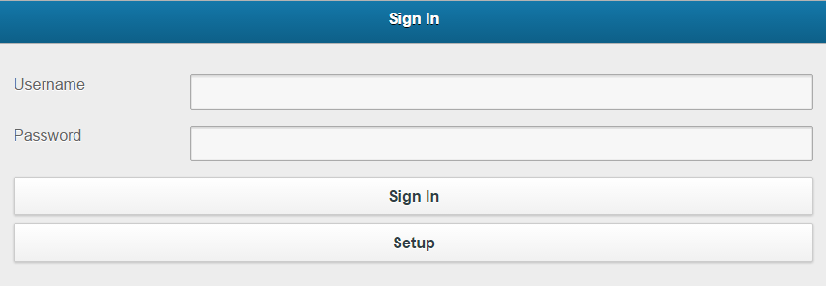

This screen appears:
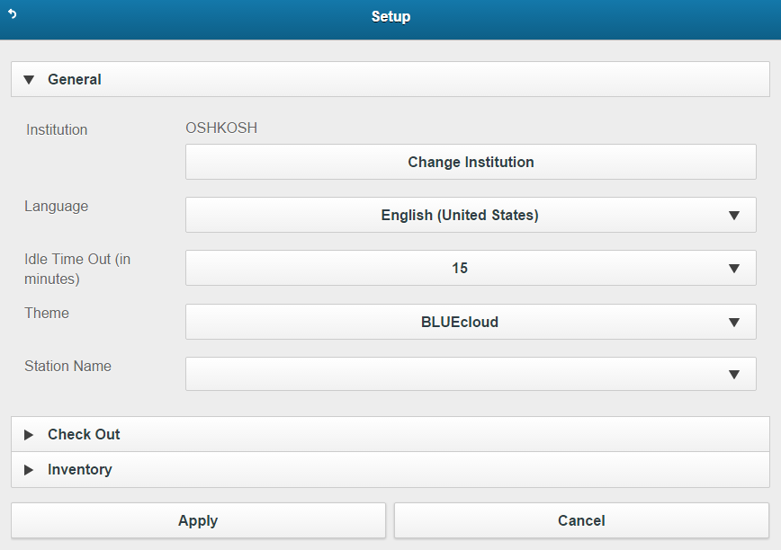

Check and make sure that your Institution is correct. If not, press the “Change Institution” button.

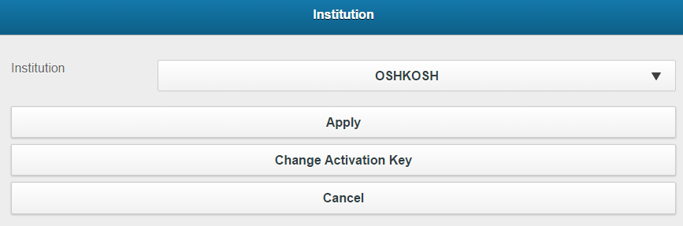

Tap the arrow and select your library from the list. Then tap the “Apply” button.
(There’s no need to press the “Change Activation Key”. If you do, you’ll have to resend it to us to reapply the activation code.)

Once you’ve verified that your Institution is correct, you can go back to the log in screen by pressing the curling arrow in the upper left corner.
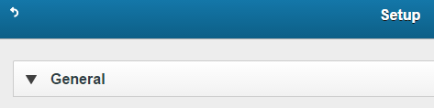

With the Institution verified, you can log into MobileCirc using your usual WorkFlows login and password.
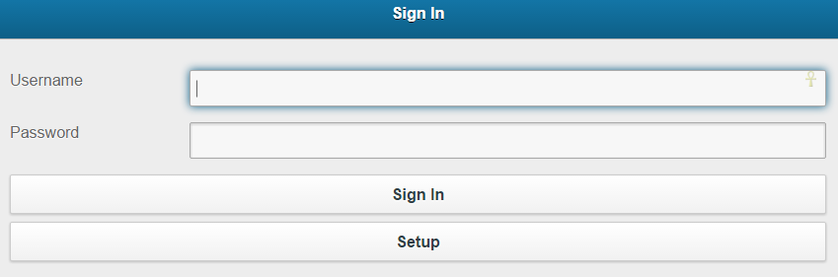
The first time you log in, you will have to do so while connected to a wireless network; after the first time, you can log in while offline.

The screen opens on the Check Out tab: 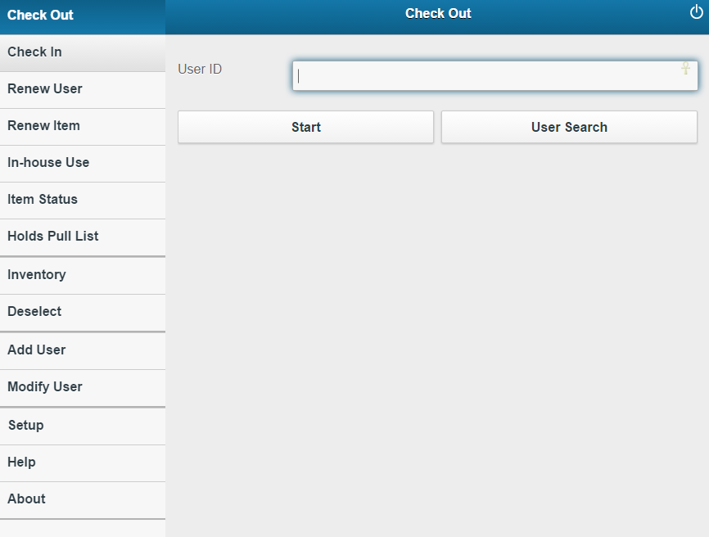

When it’s time to log off, you may do so by using the circular power icon in the upper right hand corner:
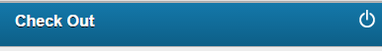

Registering Users:
Go to the “Add User” tab on the menu:

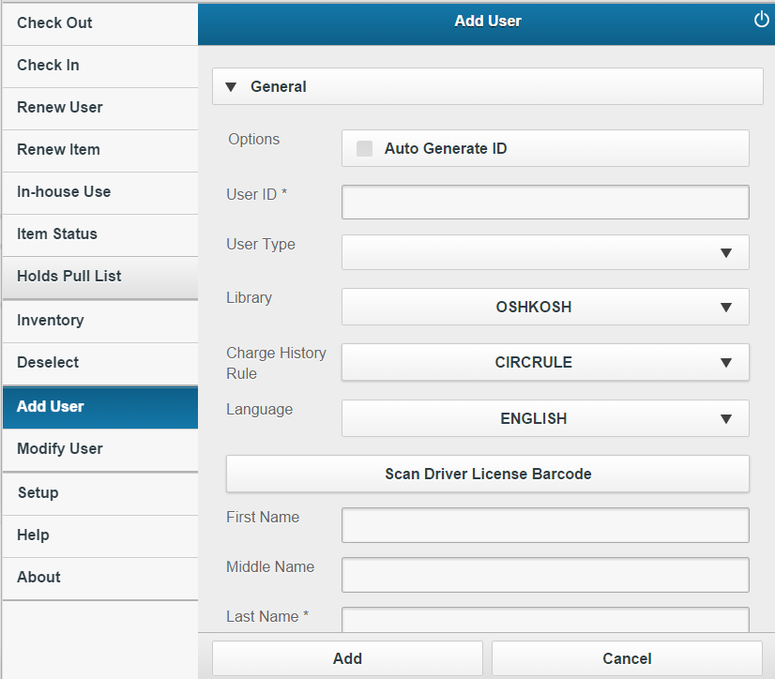

Scan the barcode of the card for the User ID field.

The User Type field is the User Profile field in WorkFlows.

The Library field should default to your library.

The Charge History Field needs to be changed to NOHISTORY, or ALLCHARGES if the patron requests their checkout history saved. It should not stay on CIRCRULE.

The Scan Driver License Barcode is a button, not a separation of fields. It should not be pressed, as we currently do not have barcode scanners that are capable of scanning the Driver License Barcode. Scroll down the device screen to see more fields:

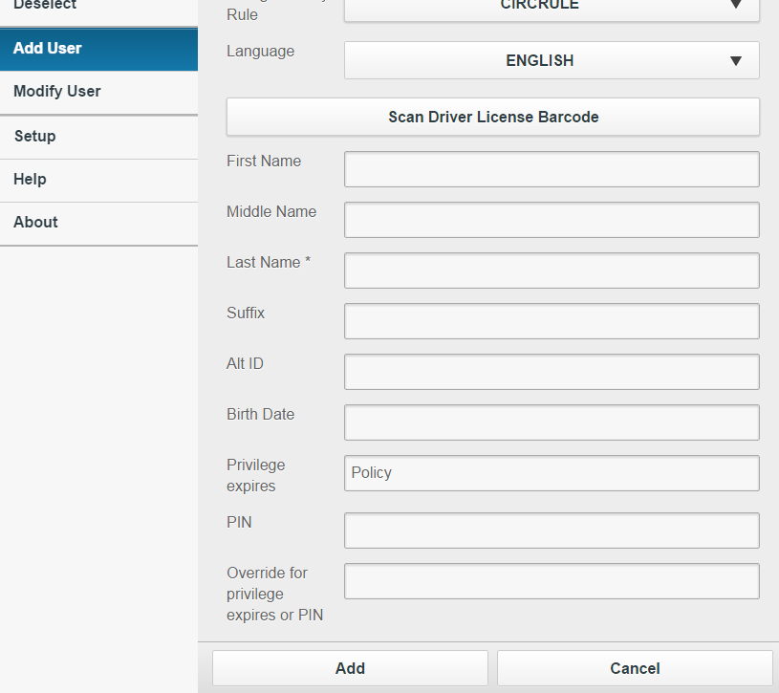

Further scrolling will be required to see all the required fields. Please remember to add a birthdate, PIN, and User Categories.

The Privilege Expires field may be left as Policy, as that will automatically apply the default expiration date from the Profile selected, once “Add” is pressed.

Weeding/Deselecting:

Before performing weeding activities with the Deselect tab, you will need to set up your Discard user. Log into MobileCirc, and go into Setup:
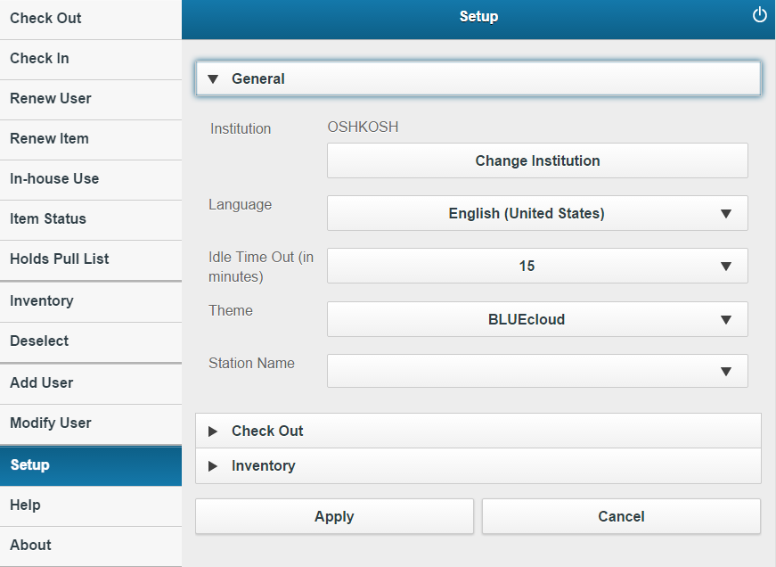

Tap the arrow next to “Check Out” to see these options:
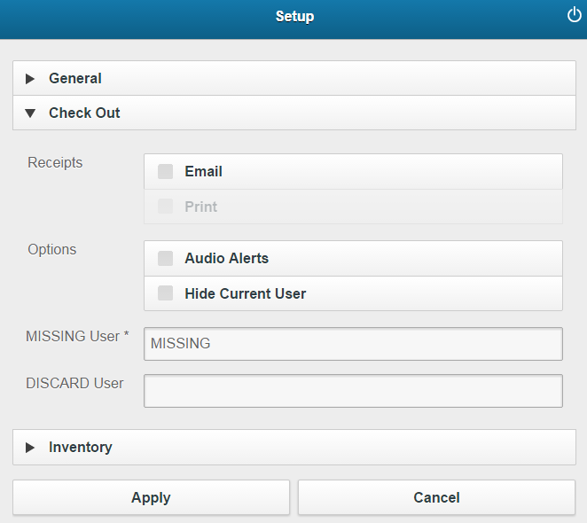

In the DISCARD user field, enter your Withdrawn card id, WD-XX, where XX is your two-letter library code (ex WD-BE=Berlin, WD-WN=Winneconne)
*Currently, MobileCirc cannot checkout items to users with more than 1000 checkouts, which includes Withdrawn users. This is a bug that is planned to be addressed.
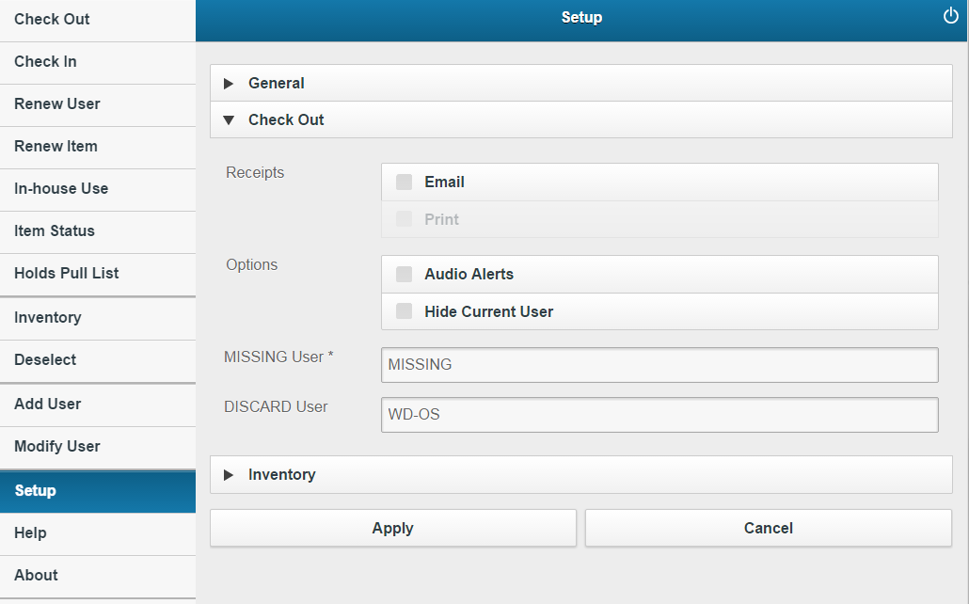

Press the “Apply” button.

You can then click onto a different tab, such as the Deselect tab:

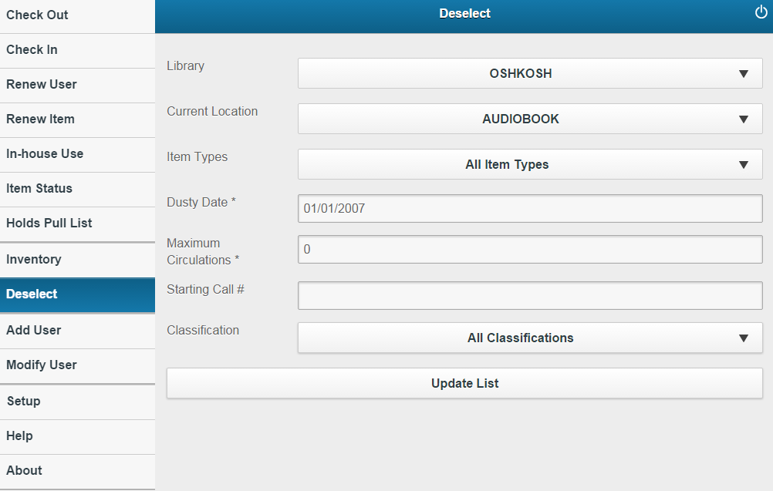

To consider items for weeding, verify the Library is correct.

Then, set the Current Location to wherever you plan on weeding ty tapping the down arrow to the right of the drop down:
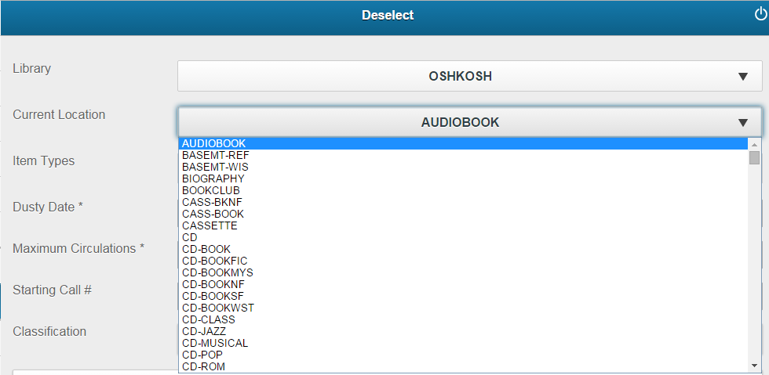

“Item Types” can be left on “All Item Types”. This will allow for items to be selected even if they have a different type than most of the items in that particular Location.

Select the “Dusty Date”, or the date the item last was checked out or checked in (or the date created if it has never been checked out) by tapping in the Date field. Use either the Calendar format or the Date format.

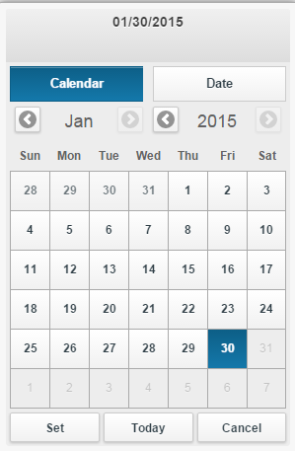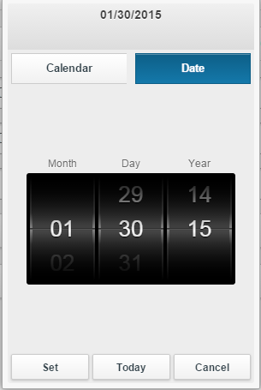

In the Calendar form use the arrows to the left and right of the months and years to scroll quickly through the months and years, then tap a specific date.
In the Date form, scroll up and down the wheel to select a date.
In both, press “Set” to set the date.

OPTIONAL: you can increase the number in the Maximum Circulations field to limit the search to only things that have circulated a set number of times. Be aware that this does NOT select items that went out x times since x/x/20xx. Usually, it is better to limit either by date OR by Max Circ.
If you are limiting by Max Circ, set the Dusty Date to a date of “Today” and key in the number of Maximum Circulations (ex, 5). That will pull back items that have circulated a maximum of 5 times, regardless of when.
If you are not limiting by Maximum Circulations, set the Dusty Date, and leave the number of Maximum Circulations as 0. This will consider all items based on their last activity, regardless of how many times they’ve circulated (weird but true).

OPTIONAL: you can key in a starting call number in the appropriate field to narrow the start of a particular area.

Once the options are set, press “Update List” to generate a list of items:
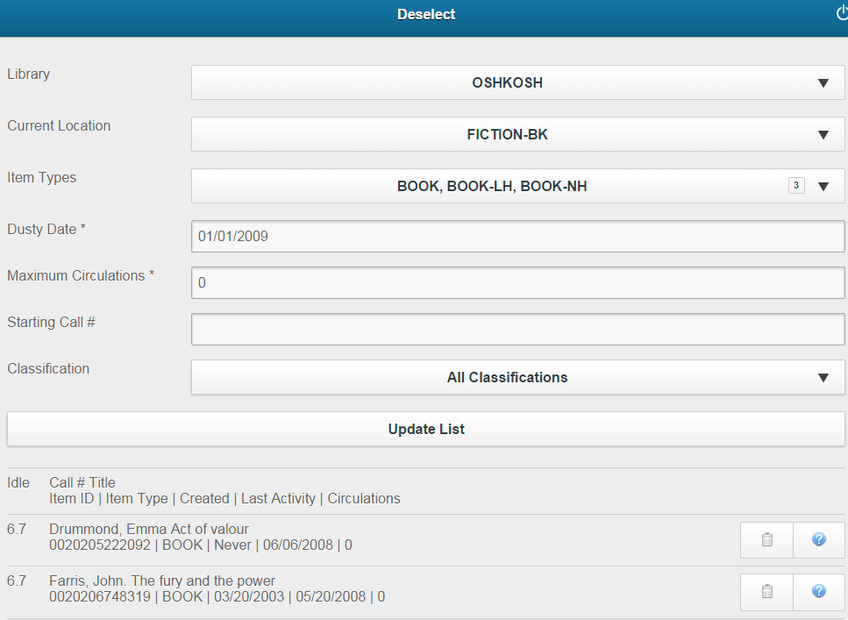

On the right side of the list are two buttons:

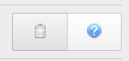
Tap the trash can icon to the right of each item to check it out to the Withdrawn user.
Tap the blue question mark icon to mark the item Missing if it cannot be located on the shelf.

On the item list, the “Idle” column indicates how the span of time since the item’s last activity (ex: 6.7 years).

The “Last Activity” column indicates the last time an item was checked out or checked in. This might not correspond to the “Last Activity” displayed for an item in WorkFlows, as WorkFlows considers a broader range of actions (such as receiving an item from transit) to determine it’s “Last Activity” field.
Usually the difference is only a matter of a few days. It is frequently seen after an item is discharged, and a few days later received from transit at its home library: MobileCirc will list the Last Activity Date as the date discharged, while Workflows will list the date that it was received from transit at its home library.

The “Circulations” field uses the “Ongoing Checkouts” field in WorkFlows, NOT the “Total charges” field. The “Ongoing Checkouts” field considers only checkouts to records added since late 2009. The “Total Charges” field considers all checkouts and renewals for all items.
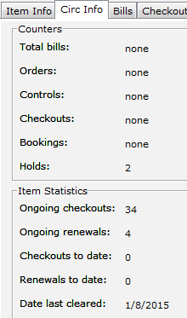

Tap on the block of item information (Call Number, Title, Barcode, etc) to see the item’s information in a shelflist browse, showing the items surrounding it and holding information:
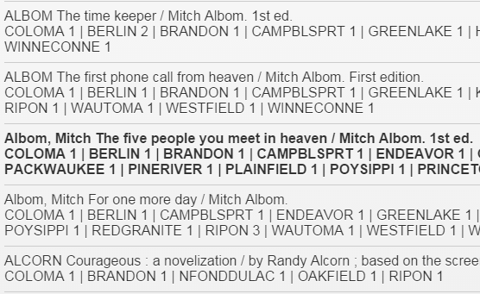

Press OK to return to the weeding list.

If you have any questions, please contact Melissa Klein at klein@winnefox.org or 920-236-5230.

